**CCENT/CCNA - ICND1 100-105**

**Chp9**

**MULTIPLE CHOICE**

1. What does ARP stand for?
   1. Address Return Protocol
   2. Apple Routing Protocol
   3. Aging Restore Path
   4. Address Resolution Protocol
2. What does a host need in order to send a packet to the router?

(choose all that apply)

* 1. Source and Destination Layer 3 address
  2. Source and Destination Layer 2 address
  3. Port number
  4. Host Name
  5. DNS domain name
  6. The MAC address of Remote Network

1. Using the following Topology create a static route from network 192.168.1.0 to 192.168.3.0.

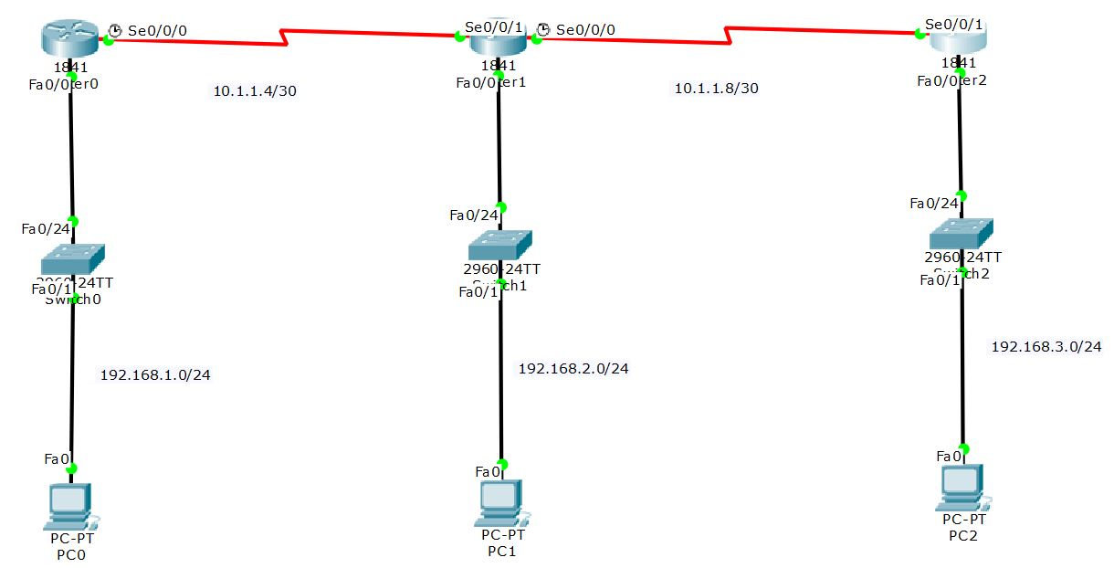

* 1. Static route destination address 192.168.3.0 255.255.255.0
  2. IP static route source 192.168.1.0 destination 192.168.3.0 mask 255.255.255.0
  3. IP static route 192.168.3.0 255.255.255.0 s0/0/0
  4. IP default route 0.0.0.0 192.168.3.0 10.1.1.6

1. Which of the following is an example of a static default route?
   1. Default route 0.0.0.0 255.255.255.255 s0/0/0
   2. Ip route 0.0.0.0 0.0.0.0 s/0/0
   3. Default information-originate
   4. IP default route 0.0.0.0 0.0.0.0 10.1.1.6
2. What command will show you the routing table?
   1. Sh ip int brief
   2. Sh ip protocols
   3. Sh ip route
   4. Sh protocols
   5. Sh controllers
3. How do you turn on DNS on a router?
   1. IP domain-lookup
   2. IP domain-name
   3. IP name-server
   4. DNS cannot be turned on using a router
4. How do you create a DHCP pool on a router?
   1. Dhcp pool 192.168.1.1 192.168.2.0 /24
   2. Pool dhcp 192.168.1.1 192.168.2.0 255.255.255.0
   3. IP DHCP pool laz
   4. IP DHCP pool 192.168.1.0 192.168.2.0 255.255.255.0
5. What command would you type on a router, to see if ip addresses are being assigned?
   1. Sh ip dhcp relay
   2. Sh ip dhcp bindings
   3. Sh ip dhcp conflict
   4. Sh ip dhcp address
6. DHCP uses a process to assign IP addresses to hosts, it’s called DORA what does the “D” Stands for?
   1. Dynamic
   2. Deprecated
   3. Denoted
   4. Discover
7. When configuring routing and you have a combination of Dynamic and Static routes, what is the syntax you must use for the static route become a backup route?
   1. Ip route 192.168.3.0 255.255.255.0 s0/0/0 backup
   2. Ip route 192.168.3.0 255.255.255.0 10.1.1.6 AD = 150
   3. Ip route 192.168.3.0 255.255.255.0 s0/0/0 150
   4. Ip route 192.168.3.0 255.255.255.0 s0/0/0 150 floating